Project Design Phase-II
Technology Stack (Architecture & Stack)
Date | 19 July 2026
Team ID
Project Name | Book a Doctor — Healthcare Appointment Booking Platform
Maximum Marks | 4 Marks

Technical Architecture:
The architectural diagram below shows how a patient, doctor, or admin interacts with the Book a Doctor application, how requests flow through the Express.js API layer, and where data and uploaded documents are stored, as per Table 1 and Table 2.
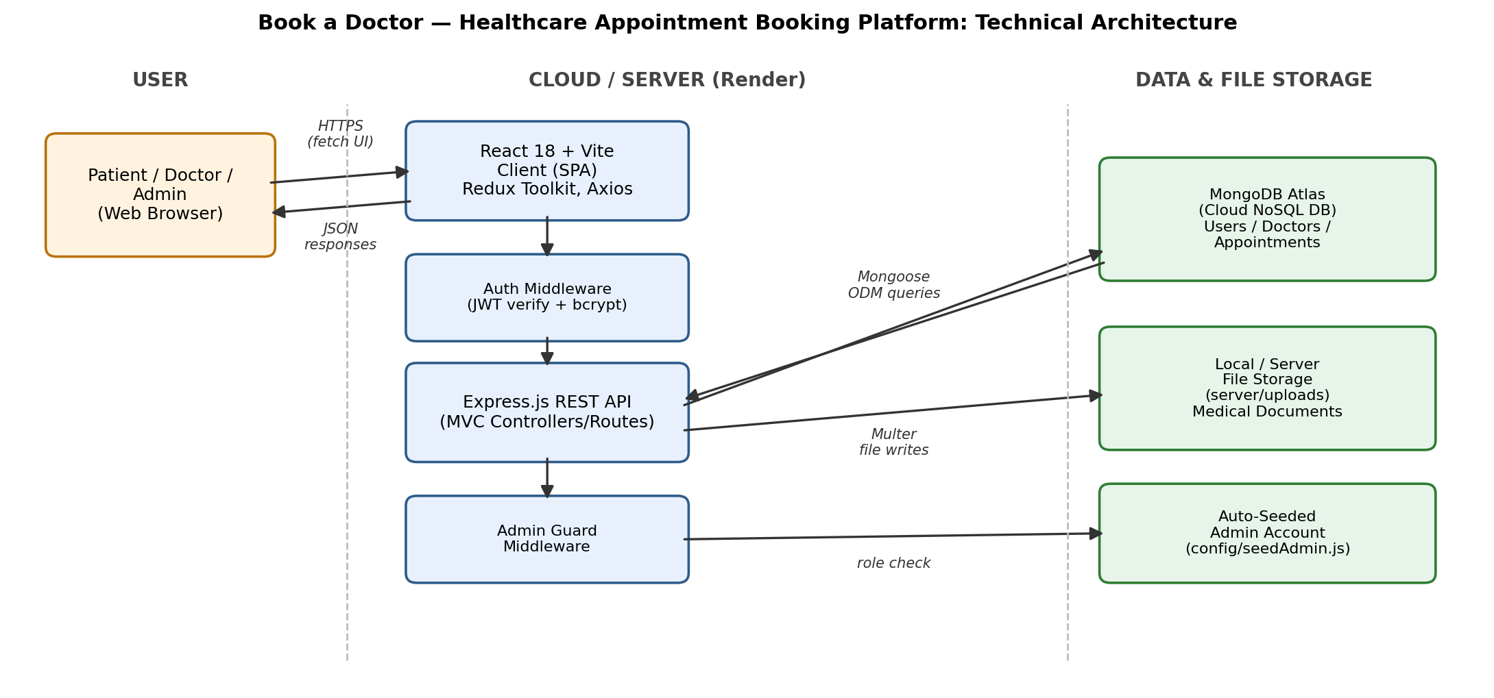 | Guidelines covered:  - All processes included as application-logic / technology blocks (client, auth, API, DB, storage)  - Infrastructure demarcation shown: local dev server vs. cloud hosting on Render  - No third-party external APIs are currently integrated  - Data storage components shown: MongoDB Atlas (cloud DB) and local file storage for uploads  - No machine learning model is used in this application

Table-1 : Components & Technologies:
S.No | Component | Description | Technology
1. | User Interface | Web UI for patients, doctors, and admin to interact with the application | React 18, Vite, HTML/CSS, Redux Toolkit, Axios
2. | Application Logic-1 | User/Doctor registration, login, and JWT-based authentication | Node.js, Express.js, bcryptjs, jsonwebtoken
3. | Application Logic-2 | Doctor profile submission, admin approval workflow, and appointment booking | Node.js, Express.js (MVC Controllers)
4. | Application Logic-3 | Role-based authorization and in-app notification handling | Express middleware (authMiddleware, adminMiddleware)
5. | Database | Stores users, doctor profiles, and appointment records (NoSQL, document-based) | MongoDB, Mongoose ODM
6. | Cloud Database | Cloud-hosted database service for production deployment | MongoDB Atlas
7. | File Storage | Storage of uploaded medical documents attached to appointments | Local filesystem (server/uploads), Multer
8. | External API-1 | Not applicable — no third-party API is currently integrated | N/A
9. | External API-2 | Not applicable — no third-party API is currently integrated | N/A
10. | Machine Learning Model | Not applicable — no ML model is used in this application | N/A
11. | Infrastructure (Server / Cloud) | Local: Node.js dev server on localhost.  Cloud: Backend and frontend deployed on Render | Local Node.js server, Render (Cloud PaaS)

Table-2: Application Characteristics:
S.No | Characteristics | Description | Technology
1. | Open-Source Frameworks | Core frameworks and libraries used to build the client and server | React, Express.js, Redux Toolkit, Mongoose, Vite, bcryptjs, jsonwebtoken
2. | Security Implementations | Stateless JWT authentication, salted password hashing, role-based access guards for doctor/admin routes, and a CORS origin allow-list | JWT, bcrypt (salt rounds), authMiddleware/adminMiddleware, CORS
3. | Scalable Architecture | 3-tier architecture (Presentation / Application / Data) with an MVC separation on the backend, allowing client and server to scale independently | React (Presentation), Express MVC (Application), MongoDB (Data)
4. | Availability | Stateless JWT auth allows the API to be horizontally scaled behind a load balancer; cloud-hosted database improves data availability | Render (Cloud PaaS), MongoDB Atlas replica sets
5. | Performance | Lightweight JSON REST responses, indexed MongoDB queries on frequently filtered fields (email, status), and a fast Vite production build for the client | Vite build optimization, MongoDB indexes, Axios

References:
https://c4model.com/
https://developer.ibm.com/patterns/online-order-processing-system-during-pandemic/
https://www.ibm.com/cloud/architecture
https://aws.amazon.com/architecture
https://medium.com/the-internal-startup/how-to-draw-useful-technical-architecture-diagrams-2d20c9fda90d

